**Netflix 2019 Data Analysis**

A PowerBI project on Netflix data from 2008 to 2019.

The first page is the home page where the overview of the dataset is stated with the country, year and category can be evaluated.

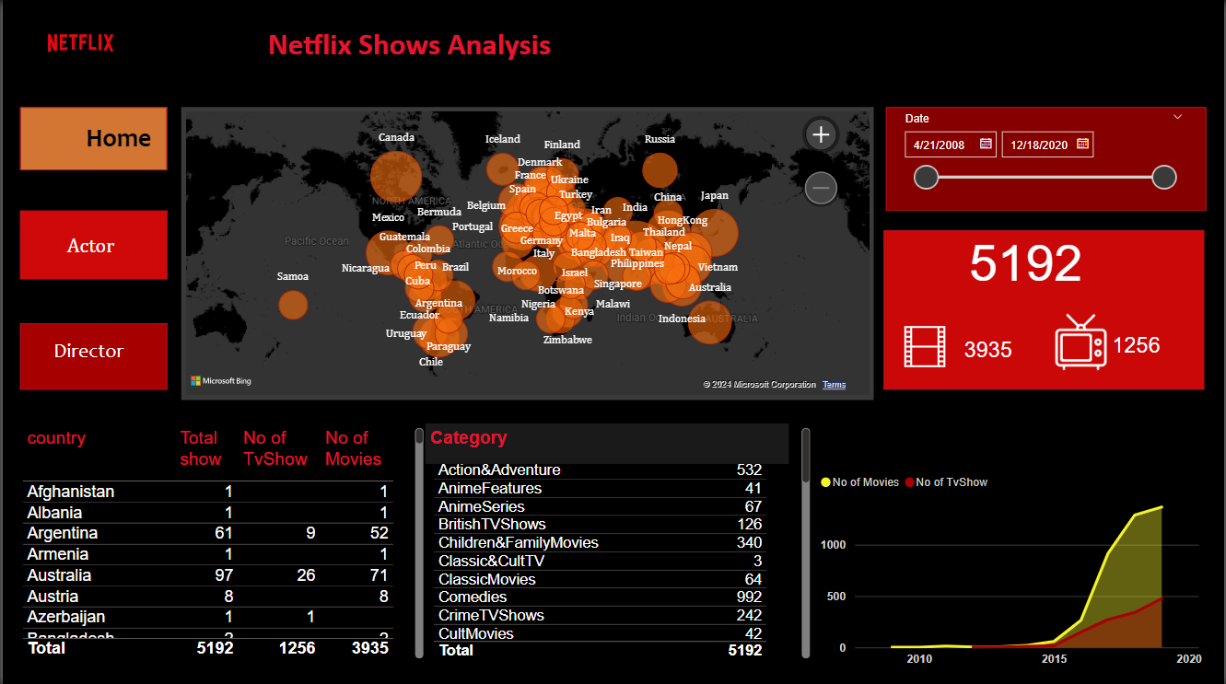

The second page is for analyzing the actor and actress in terms of their movies/TV series number and category of works.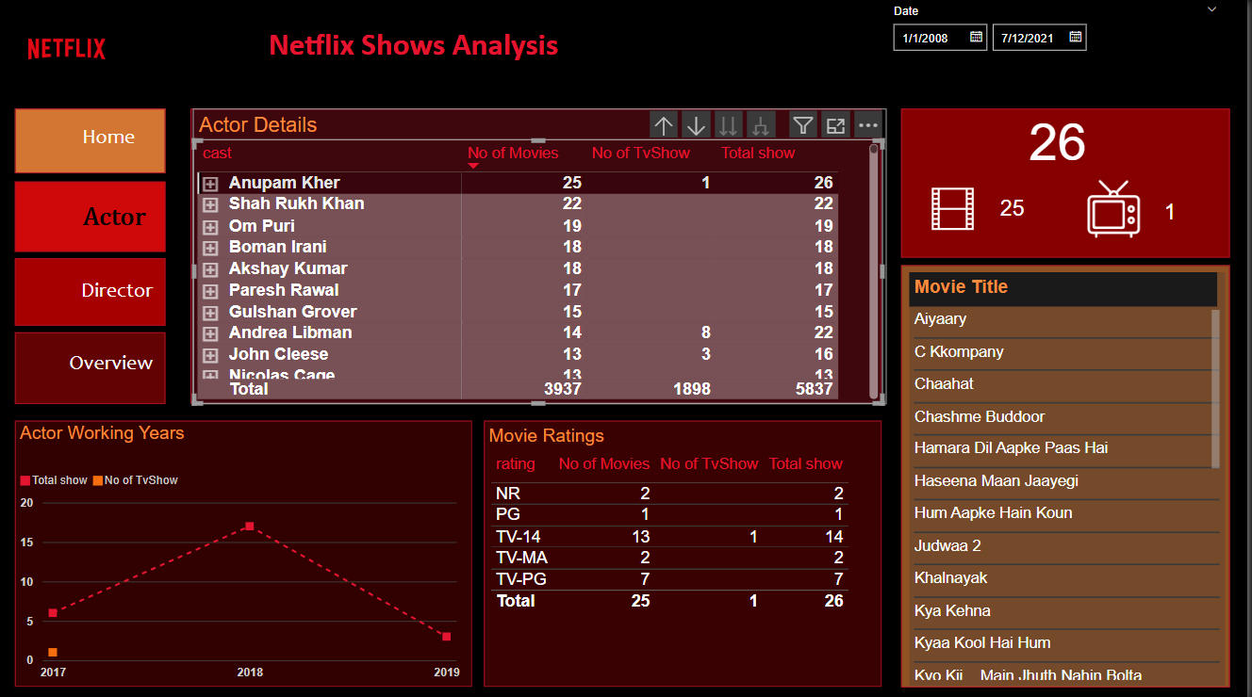

The last and third page is for director's performance analysis

